STUDY OF 2M*2M GLASS RESISTIVE PLATE CHAMBER
(RPC) AND ITS CHARACTERISATION

Report submitted in fulfillment of the VSRP-2011
Under the guidance of

Prof. Naba Kumar Mondal / Dr. B Sathyanarayana
By
Krishnaparvathy.P
NIT Calicut, Kerala

INTRODUCTION

Ever since neutrino discovery it still remains to be a mystery among the fundamental particles. The existence of non-zero neutrino masses has profound implications on various fields as nuclear physics, geophysics, astrophysics and cosmology. The experimental field of neutrino physics is now moving into a phase where decisive and high precision experiments are needed. India-Based Neutrino Observatory (INO) is an initiation for this. it will enable us to study the oscillations of neutrinos and its properties.

INO plans to build a magnetized modern calorimeter for the detection of neutrinos. The detector will be placed inside a mountain at Pottipuram, Theni near Madurai in South India. This Iron Calorimeter (ICAL) detector consists of a massive electromagnet (50 Kton).The ICAL uses the glass Resistive Plate Chambers (RPC’s) as the active detector element. RPC is a gas based ionization detector. RPC comprises of two parallel plates of glass and held together by spacers which maintain a gap between the glass plates. A suitable gas mixture is flown at the atmospheric pressure through the gap while an appropriate electric field is applied across the glass electrodes through a resistive coating on their outer surfaces. When a charged particle passes through the glass plates, it will ionize the gas inside and produces electron- ion pair. Due to high electric field secondary ionization will happen and result in local discharge of electrons. This discharge will be only in a small area due the resistive coating on the glass plates and quenching property of the gas. The pickup plates outside the glass plates will pick the electrical signal produced and fed to data acquisition system (DAQ). From the collected data we will analyze the coordinates and time of flight of the tracked particles.
The Iron calorimeter. Resistive Plate Chamber.
CONSTRUCTION OF RPC
- Cutting and cleaning of glass
We use float glasses to make RPC because the bulk resistivity of glass is very high about 10¹⁰ to 10¹² Ω-cm. The discharge produced after avalanche is limited to a tiny area of about 0.1cm² due to the high resistivity of the glass electrodes. The glasses are cut by diamond cutter to the appropriate size and the four corner edges are chamfered by a jig of right dimension to make a correct 45⁰ angle. The glasses are thoroughly cleaned with alcohol and then labolene and distilled water. After that the edge spacers, corner spacers (which are connected to the gas nozzle), button spacers (used for bigger RPCs) are cleaned with alcohol.
- Conductive coating
Conductivity of the glass is increased by coating one side of it with a mixture of dry colloidal graphite and industrial lacquer in a ratio of 1:8 using a spray gun. We use graphite because it has got high conductivity, chemical resistance and good mechanical properties. Graphite forms no compounds due to corrosion, no protective surface films as do many metals. The surface resistance is found to be fairly constant and is about 400KΩ/cm².
- Gluing of glass
The glue used is 3M Scotch-weld epoxy adhesive in a duo-pack cartridge. Polycarbonate buttons shaped spacer, with bulk resistivity greater than 10¹³ Ω – cm are glued first at the centre and and at some specific places..After that the edge spacers are glued. The gas inlet and outlet pipes are also fitted to the edges.
- Gas leak test
Now the RPC has become ready to be tested to make sure that no gas leak occurs, especially at the glued joints. This is done by flowing Freon gas at atmospheric pressure and checked for any leak using a gas sensor FLON GH-202F.
- High voltage cables and pick up strips
Base of the RPC is wired by high voltage cables. The high voltage is applied to the graphite layer by sticking on a copper tape and leads are then soldered on to the copper. Positive voltage is applied to one side and a roughly equal and negative voltage to the other side. The RPC is now sandwiched between two honeycomb pickup panels placed orthogonal to each other and then packed in an aluminium case. The pickup panel consists of 64 strips copper foil on one side of a layer of 5mm of foam and aluminium on the other side Each strip is terminated with a 50Ω impedance to match the characteristic impedance of the preamplifier. A layer of Mylar of thickness 100 μm is placed between the graphite layer and the pickup panel to provide insulation.
PRINCIPLE OF OPERATION

The detector working concepts are based on the detection of gaseous ionization produced by charged particles traversing the active area of the detector, under a strong uniform electric field applied by resistive electrodes. The chamber is filled with a proper gas which gets ionized when a sufficiently energetic radiation penetrates the chamber thereby resulting in the formation of electron ion- pairs. Owing to the high resistivity of the electrodes, the electric charge quickly dies off in a very limited area (typically 0.1 sq.cm) around the points where the discharge occurs. The discharge produces signals which are counted and analyzed by appropriate read out electronics.
Modes of Operation:-
There are two modes of operation for RPCs, i) Avalanche Mode and ii) Streamer Mode.
1.) Avalanche Mode: Ionized particles, created by primary ionization of gas through charged particles are accelerated by the electric field and in their way to the electrodes they ionize the gas again to set in an Avalanche process. However this process stops as the internal opposite field is balanced by the external field and the charges are collected in the respective electrodes. The pulse height in this mode is of the order of few milli volts and amplifiers are required in this mode of operation. This mode is also called proportional mode.
2.) Streamer Mode: In this mode of operation, the electric field inside the gap is kept intense
enough to generate limited discharges localized near the crossing point of the ionizing particle. The avalanche is followed by a streamer discharge and signal generated will be large in the order few hundreds of milli volt. Hence no amplifiers will be needed.
A typical RPC Pulse
PRE AMPLIFIER TESTING
Preamplifiers are used to amplify the weak signals from a detector and drive the signals through the cable. Here we will test the preamplifiers with a pocket pulsar which gives us a negative signal. This will be connected to attenuators. Using this we will adjust the input voltage. The input and output signals can be seen from oscilloscope. We will measure the gain for different voltages.
POSITIVE PREAMPLIFIER:- NEGATIVE PREAMPLIFIER :-
0
20
40
60
80
100
45
50
55
60
65
70
75
80
85
90
95
Negative Preamplifier
Channel - 1
Channel - 2
Channel - 3
Channel - 4
Channel - 5
Channel - 6
Channel - 7
Channel - 8
Gain
Voltage(mV)
From the above graphs it is observed that the gain of the preamplifiers is around 80.
CHARACTERISTICS OF RPC
- I – V Characteristics
This is the first characteristic test after the RPC fabrication. We will apply voltage to two glass plates from 0 to 5500 and we will note down the current. From the graph we will analyze the working of RPC.

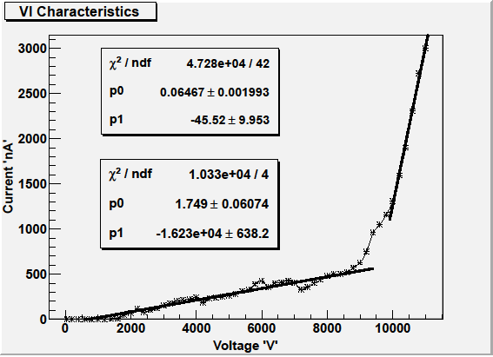
Gap resistance (Low voltage) = 15.4631GΩ ; Glass resistance (High voltage) = 0.5717GΩ
This plot can be explained using the electrical model of RPC(right side figure).It is observed that the region(less than<9500) is almost linear and it is corresponds to the ohmic region. In this region the spacer resistance will be only there and gap resistance will be infinite. So it acts as ohmic. At high voltage gap resistance will be close to zero and the circuit will look like circuit having two parallel resistances. So there will be a sharp increase and it occurs when avalanche of electron - ion pair starts and break down occurs. This is the active region of RPC.

2 . Efficiency plot
The efficiency of RPC is calculated with respect to cosmic ray muon telescope as reference. The telescope consist of 4 scintillator paddles. The areas of these paddles are 60 cm × 20 cm,60 cm × 20 cm, 30 cm × 3 cm, 30 cm × 2 cm, 40 cm × 20 cm and 40 cm × 20 cm respectively and are arranged in such a way that they will be in coincidence. They are optically coupled to a PhotoMultiplier Tube (PMT) for converting the scintillation light into an electrical signal. A trigger will be produced when a charged particle may be muon passed through all the 4 paddles. This trigger and RPC pulse will be given to an AND gate. From this trigger and trigger with RPC pulse we will calculate the efficiency. 2m*2m RPC consist of 64 strips in X-side and 64 strip in Y-side. From this we will take 3 strips for our calculation. Here we took right (S19), main (S20) and left (S21) strips. Efficiency is calculated and plotted as a function of voltage applied. For voltages from 9000 to 10000 we calculated the efficiency for 3hour run.
It is observed that the efficiency values are almost constant for voltages higher than 9.7kV but falls sharply with decreasing voltage below it. The horizontal part of the plot in the high voltage region is known as plateau region of operation of the RPC.
3 . Threshold – Noise plot
Threshold of the electronic systems are set according to this calculation; mainly discriminators threshold .We varied the threshold from 15mV to 80mV and we measured the count rates of all strips in one second. Since the system was getting noisy we could not able to go down than the 15mV.

From the above the plot we decided to put the value of threshold at 30mV.
GAS FLOW SYSTEM
The choice of filling gas for RPCs is governed by several factors: low working voltage, high gain, good proportionality and high rate capability. The ionization potential, the Townsend co-efficient and the electronegative attachment co-efficient determine the avalanche multiplication, the presence and relative importance of photo production, the saturated avalanche range to the streamer mode.
Currently the RPCs are operating in the avalanche mode and hence the main component could be an electronegative gas, with high enough primary ionization production but with small free path for electron capture. The high electronegative attachment coefficient limits the avalanche electrons number. Tetrafluoroethane (known as Freon), which is widely used, has shown these specifics. But here we use R134a(as Freon) which is eco-friendly. One more component is constituted by polyatomic gases, often hydrocarbons, which have a high absorption probability for ultra violet photons, produced in electron-ion recombination. This gas is known as quenching gas. This component allows to the energy by vibrational and rotational energy levels, avoiding photo ionization with related multiplication and limiting the lateral charge spread. Here we have used Isobutane as the quenching gas. Finally we use SF6 (Sulphur-hexafluoride) to control the excess number of electrons.
Gas used | Avalanche | Streamer
Argon | 0.0 | 30.0
Freon(R134a) | 95.5 | 62.0
Isobutane | 4.3 | 8.0
SF₆ | 0.2 | 0.0
The gas system consist of following components : -
- Purifier column: - It contains Molecular sieve used to absorb moisture and purify it .
- Mass Flow controller (MFC):- It will control the flow rate using supplied voltage.
- Mixing unit:- Based on Mass Flow Controllers (MFC) and the flow of the gas is displayed in Standard Cubic Centimeter per Minute (SCCM).
- Distribution panel:- 16 RPC's can be connected in parallel, which is achieved by Flow resistors called Capillaries.
- Safety bubbler’s:- To take care of the back pressure exerted and protect the RPC's from over pressurizing.
- Isolation bubbler’s:- It prevents back diffusion of air into the RPC and also the indicate the flow of the gas.
- Exhaust manifold:- All the gas to be vented is collected in this manifold and a single output is provided to vent the used gas into the atmosphere. This manifold has a pressure sensor to indicate the pressure with respect to the room pressure.
- Moisture meter:- Microprocessor based sensor meter to monitor the moisture content in the mixed gas.

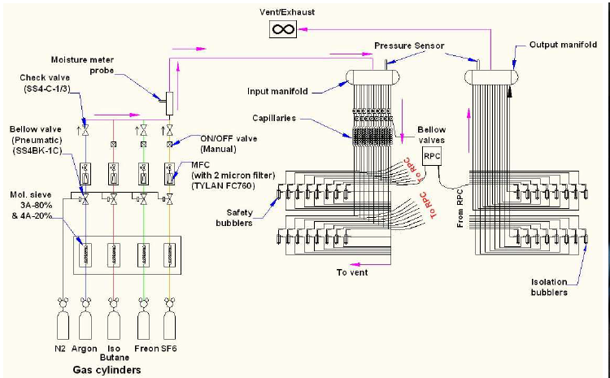

CONCLUSION
The construction of 2m*2m RPC studied and its different characteristics also studied. From the above results it is come to know that the operating voltage of RPC is 9.8 kV. From the preamplifier testing it is came to know that the gain of the preamplifiers is around 80.The counting rates Vs threshold was calculated and we set the threshold of electronic system at 30mV. We also studied about gas systems, importance of each gas in the system, how each unit works and we did the calibration of gas flow. The high voltage test for scintillators and studied about different parts of the scintillator detector.

FUTURE WORK
Construction of scintillator is going on. Taking samples for DRS and its studies is the other work. RPC’s for INO are being constructed and its studies will be continuing. Electronics setup is being modified.

REFERENCES
- David Griffiths (1987), Introduction to Elementary Particles, John Wiley & Sons, 22-28.
- Glenn F.Knoll (2009), Radiation Detection and Measurement, John Wiley & Sons, 714-722.
- B Satyanarayana, Design and Characterisation Studies of Resistive Plate Chambers.
- Personal Website of Satyanarayana Bheesete: http://www.hecr.tifr.res.in/~bsn/ino.html.

ACKNOWLEDGMENT
I am really very thankful to GOD who chose me for doing work in such a great institute.
I would like to thank Dr. Naba Kumar Mondal for giving me an opportunity to work on the Different aspects RPCs in the ForwardC-217 lab and new INO lab.
I also appreciate the invaluable help and guidance of Dr. B Satyanarayana and his valuable time and proper guidance without which i could not be able to learn advancement in my learning.
Mr. Ravindra Shinde is to whom I must dedicate this project for without him I would not be able to finish this. He taught me everything that I learnt here. I shall be eternally grateful for all that he has done for me.
I am also indebted to Mr. Mandar, Mr. Shekhar, S.S Chavan, Manas Bhuyan, Vishaal, Mr.Reddy, Mr.Varma and every lab member for their suggestions for the same
I thank Mr. Gopal krishna, the VSRP Students and the INO students for making my stay in Mumbai a memorable one.
. I would also like to express my gratitude to my family and friends for their support and guidance.

