PERFORMANCE STUDY OF WIZNET 5300
A PROJECT REPORT
Submitted by
ANKITA BANSAL
Of
THE LNM INSTITUTE OF INFORMATION TECHNILOGY
Jaipur, Rajasthan

UNDER THE GUIDANCE OF
S. S. Upadhya
Scientific Officer (F)
And
Mandar Saraf
Scientific Officer (C)
Department of High Energy Physics
TATA INSTITUTE OF FUNDAMENTAL RESEARCH
Mumbai, Maharashtra
CONTENTS
- Abstract
- Introduction
- W5300
- Features of W5300
- Functional Description
- TCP/IP
- Wiznet as Client, PC as Server
- TCP Client Operational Flow
- Results
- Connection establishment after each transmission
- Long term stability
- Wiznet as Server, PC as Client
- TCP Server Operational Flow
- Results
- UDP
- Wiznet as Client, PC as server
- UDP Client Operational flow
- Results
- Wiznet as Server, PC as Client
- UDP server operational Flow
- Results
- Comparison between TCP and UDP
- Conclusion
- Reference

ABSTARCT
The aim of this project is to understand the functionality and performance of Wiznet Ethernet chip W5300 so as to adopt this chip to develop an internet connection between back-end PC and RPC-DAQ board planted in each of Resistive Plate Chamber, a detector element of the upcoming INO_ICAL detector. Here, we have focused on data through put rate and reliability of W5300 chip and tested few suitable protocols supported by the chip. The RPC-DAQ is planned to be built around embedded processor NIOS-II in FPGA to control and acquire data from 128 channels in a RPC. The RPC DAQs are linked to back end PCs via network switches using Ethernet interface chip Wiznet W5300. The communication and data transfer between these front and back end systems are planned in Client – Server mode.
A setup is made to interface NIOS II processor with W5300 in memory mapped IO configuration using an Altera FPGA Cyclone IV based development kit DE2-115. The W5300 is connected to a PC via network switch. The programs are developed to understand mainly TCP and UDP protocols and several tests are conducted between these two nodes. The performance of W5300 is satisfied up to the manufacture specifications. The tests and results are discussed in this write up.

INTRODUCTION
INO_ICAL:
The India-based Neutrino Observatory (INO) collaboration is planning to build a massive 50kton magnetised Iron Calorimeter (ICAL) detector, to study atmospheric neutrinos and to make precision measurements of the parameters related to neutrino oscillations. Good tracking, energy and time resolutions as well as charge identification of the detecting particles are the essential capabilities of this detector. The ICAL detector is built in 3 modules of dimension 16mx16mx14.5m having 150 layers of RPCs sandwiched between 56mm thick Iron plates. The glass RPC of dimension 2mx2mx24mm consists of 64 signal strips on top and bottom orthogonal to each other. A total of 3 million channels from 30 thousand RPCs are to be processed for trigger and readout of data.
The Test setup for feasibility study of W5300:
The setup is mainly built for feasibility study of W5300 interface with NIOS for the RPC-DAQ. The NIOS II core with necessary peripherals and memory map interface to Wiznet W5300 chip is embedded into a CYCLONE IV FPGA in the Altera development kit DE2-115. The W5300 module is wired to NIOS II as a memory mapped IO. The W5300 module is connected to a PC under Linux using a 10/100Mbps network switch. The client server programs in C are written for NIOS II under Altera software environment. Similarly programs are developed in C under Linux for PC Client and Server.

Feasibility Study of Wiznet 5300 interface

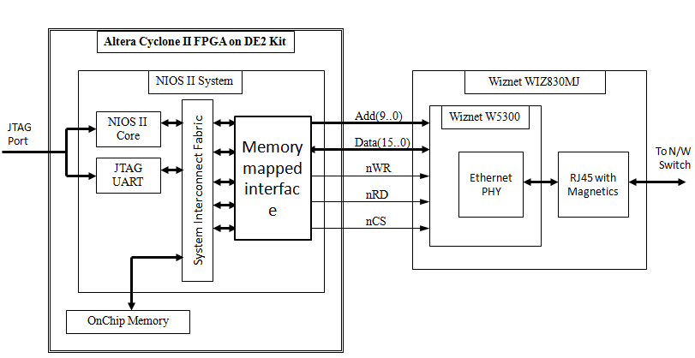

Test setup

W5300
W5300 is a 0.18 µm CMOS technology single chip into which 10/100 Ethernet controller, MAC, and TCP/IP are integrated. W5300 is designed for Internet embedded applications where easy implementation, stability, high performance, and effective cost are required.

FEATURES OF W5300
High-Performance Hardware TCP/IP single chip solutions
WIZnet chip W5300 contains the technology of full hardware logic of communication protocols such as TCP, UDP, IPv4, ICMP, IGMP, ARP and PPPoE. In order to provide high-performing data communication, the data communication memory is extended to 128kbyte and a 16bit bus interface is supported in W5300. Users can utilize 8 independent hardware SOCKETs for high-speed data communication.
More flexible memory allocation for various applications
The memory for data communication can be allocated to each SOCKET in the range of 0~64Kbytes. It is more flexible for users to utilize the memory according to their application.
Easy to implement
W5300 supports BUS interface as the host interface. By using direct and indirect access methods, W5300 can be easily interfaced to the host like an SRAM memory. The data communication memory of W5300 can be accessed through TX/RX FIFO registers that exist in each SOCKET.
High Data Transmission Rate
High performance network speed of up to 50 Mbps can be achieved with W5300.

FUNCTIONAL DESCRIPTION
W5300 can provide Internet connectivity simply by setting some registers. When the initialization is successful, W5300 is available for data communication through Ethernet. After initialization, W5300 can transmit or receive data by opening the SOCKETs in TCP, UDP, IPRAW, or MACRAW mode. W5300 supports 8 SOCKETs to be used independently and simultaneously.

TCP/IP
TCP is the connection-oriented protocol. In TCP, a connection SOCKET is established by pairing its IP address & port number with the peer’s. Through this connection SOCKET, data can be transmitted and received.
There are "TCP SERVER" and "TCP CLIENT" in the method of establishing connection SOCKET. The method can be distinguished according as who transmits connect-request (SYN packet). "TCP SERVER" waits for connect-request from the peer, and establishes the connection SOCKET by accepting the request (Passive-open). "TCP CLIENT" transmits connect-request to the peer to establish the connection SOCKET (Active-open).
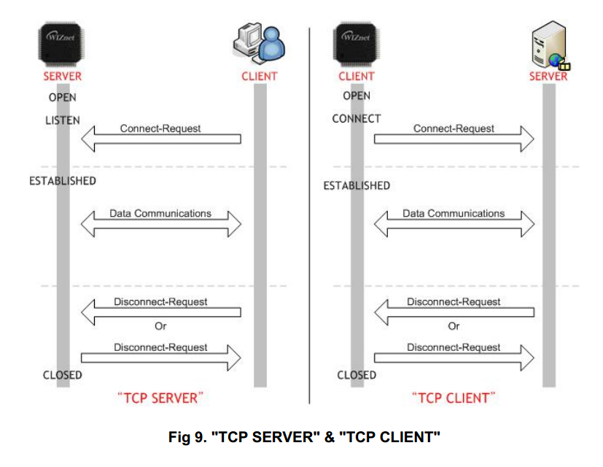
WIZNET AS CLIENT, PC AS SERVER
As in the final setup of RPC-DAQs majority of time, data needs to be sent from DAQ to PC so we used wiznet as a client and PC as server here, thus transferring data from wiznet to PC.

RESULTS

DATA through put
Wiznet as a client establishes connection with Server in PC. The data packets are send continuously up to 50000 packets to calculate the overall throughput rate. The data through put depends on number of sockets are also performed. The study is done with NIOS filling up the data into Tx FIFO of Wiznet socket before sending each packet over network as well as retransmitting the packet data from Tx FIFO with one filling at the beginning. Later study is done with two clock speed of NIOS. The results are summarized below
1280bytes /packet, 50000 packets
 | Writing in FIFO every time |  | Writing in FIFO only once
NIOS2 clock frequency | Single socket | Multi sockets (4 sock here) | Single socket | Multi socket (4socket here)
50 MHz | 10.3 Mbps | 11.5Mbps | 61.3 Mbps | 94 Mbps
100MHz | 18.3Mbps | 22.4 Mbps | 90 Mbps | 100 Mbps

The through put did not show much improvement with increase in the number of sockets used. A large improvement close to its maximum capacity is seen in the transmission of data packet without writing to FIFO every time.
The time taken to fill up the Tx_FIFO up to 1280 bytes and give a send command is measured using scope by setting and resetting a port of the NIOS before and after the write function. The results are tabulated below.

Time measured with 1280 bytes/packet
NIOS2 clock frequency | Time taken in writing to FIFO (per byte) | Time taken in sending data (per byte)
50 MHz | 0.67 micro sec | 0.08 micro sec
100 MHz | 0.35 micro sec | 0.08 micro sec
The time of 0.67x2 = 1.34µs per 16 bit word write cycle to FIFO is quite high as compared to the W5300 chip write cycle specification of 80ns. The recalculation of through put assuming FIFO 16bit write cycle time of 100ns, comes to around 50Mbps which is mentioned in the W5300 specification. So, the above data signifies that throughput can be optimized by reducing the write cycle time.

Establishing connection for each packet transmission
In the ICAL detector, random events leave their localized signature of tracks of interactions in the detector in few layers of RPCs. With few Hz of trigger rate and few RPC participation each event randomly, it may be appropriate to send RPC data by establishing connection for the data transfer period with back end PC servers as when necessary. So, the throughput of connection establishment per packet data transfer is planned and results are tabled below.

RESULTS
1000bytes/packet, 50000 packets
NIOS2 clock frequency | Single socket
50 MHz | 2.3 Mbps

Here you can observe data throughput reduced to 2.3Mbps as compared to 10Mbps speed of multiple packets transmission per connection. The average time taken in establishing and closing the connection is calculated by subtracting data transfer time and is approximately 3msec

Check for Long Term stability
When we are sending data at random intervals of time in the range of 0 to 10sec, no error was found in the data at the server end and data transfer ran for 7 hours without any discontinuity satisfying the long term stability of the system.
- Establishing the connection only once and retaining till end of all the packets
- Packet size = 1280 bytes
- Same data in all the packets
- No of packets sent = 7920
- Expected time to complete data transfer :
11 hours (calculated by taking the mean interval of 5 sec)
- Actual time taken to complete data transfer is 7 hours

Wiznet as Server, PC as client
Here wiznet is used as a server and PC as a client.

TCP SERVER OPERATION FLOW

RESULTS
The above discussed tests are repeated by changing the client-Server role between W5300 and PC. The similar results are seen as below.
1280 bytes/packet, 50000 packets
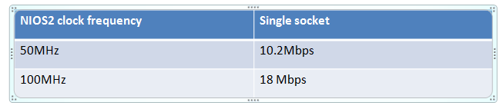
Data rate is same as in the case of Wiznet as a client.
NOTE: Here while sending data from PC to Wiznet, since the clock speed of PC processor is very fast and NIOS-II processor is comparatively slow, we need to give certain delay on PC side before sending each packet so that wiznet gets enough time to read data from the buffer.
For our purpose we have given 1000 µs delay after each packet is sent from PC (client) to Wiznet (Server).

UDP
UDP is a connection-less protocol. UDP transmits or receives data without establishing a connection SOCKET as TCP does. TCP guarantees reliable data communication, but UDP doesn't. UDP is a datagram communication protocol. As UDP doesn't establish a connection SOCKET, it is allowed to communicate with multi-peers that already know about the source IP address and the source port number. This datagram communication has the ability to communicate with multi-peers through one SOCKET, but a possible problem is to lose data or to receive data from undesired peers. In order to prevent the problem, the host itself should re-process the lost data or ignore the received data from the undesired peer. UDP supports unicast, broadcast and multicast method.
In the INO ICAL setup, we may need to send common commands or initialization data from back end to all the RPCs. So, we may have to use broad cast or multicast using UDP protocol. We may dedicate one of the sockets in the wiznet for this purpose as server in UDP mode.

Wiznet as Client, PC as Server
As in the final setup of RPC-DAQs majority of time, data needs to be sent from DAQ to PC so we used wiznet as a client and PC as server here, thus transferring data from wiznet to PC.
UDP Client Operational Flow

Open Socket

WRTOFIFO
Send Data
Yes
Close Socket
Dest.Hard.addr?
Send OK?

No
No
Time out
Yes

RESULTS

1000 bytes/packet, 50,000 packets
NIOS2 clock frequency | Single socket
50 MHz | 10.5 Mbps
100MHz | 18.3Mbps

Data rate is similar to that of TCP multiple packet transfer in single connection which resembles like UDP except for some minor reduction UDP header size.

Wiznet as server, PC as Client
Here Wiznet is used as Server and PC as Client.

UDP Server Operational Flow

Open Socket
yes
No
yes
Socket close
Finished?
Receiving process
Receving data? ?datadata?
No

RESULT
Maximum Receiver buffer FIFO size in W5300 can be set as 64kbytes per socket. In the UDP, data packets are sent continuously as PC is fast and Wiznet side NIOS processor cannot match with this speed reading the data from socket receiver buffer FIFO due to large read cycle time. Hence, data over flow is seen in the FIFO and loss in excess data as there is no acknowledgement per packet in UDP protocol. The half a second delay between successive sent packet reduced the data loss to 5%. So, the UDP protocol may not be advisable for RPC data transfer to back end unless there is a customized hand shake on data transfer reliability.

Comparison between TCP and UDP

50 MHz NIOSII clk frequency | TCP | UDP
Data Rate | 10.3 Mbps | 10.27Mbps
Data reliability | All the bytes sent are received at the destination correctly. | While using wiznet as UDP server approx 5% of data loss is observed due to mismatch in PC processor and NIOSII processor speed.

In our results data speed of TCP and UDP is same because in TCP connection while calculating data rate we are not taking into account the connection establishment time which brings the major difference while calculating data transfer speed.
While designing Wiznet as UDP server, data transmission is not reliable as all the packets sent by client are not received by the serve due to the mismatch of PC processor and NIOS processor speed.

Conclusion
While using Wiznet in TCP mode Data Transmission is reliable as every byte sent is received correctly at the destination. Majority of time is spent in “writing to FIFO”. Aim should be to reduce this time to increase the data rate. We are able to achieve 18 Mbps data rate (for single socket) by increasing the NIOS2 clock frequency up to 100MHz. If we can reduce the FIFO write time up to 50ns/byte (minimum time as per datasheet of W5300) then the throughput rate estimation is coming near to 50 Mbps. Also we observed that the optimal packet size for data transfer is 1280 bytes.
While using the UDP protocol it is advisable not to use wiznet as server when client is faster like PC for large data transfer. The UDP may not be reliable for deterministic data transfer.

Acknowledgement
I wish to express my sincere gratitude to S.S.Upadhya, scientific officer (F) in DHEP department, TIFR, Mumbai for providing me an opportunity to do my project work on “Performance Study Of W5300”. This project bears an imprint of many peoples. I sincerely thank to my project guide Mandar Saraf, Scientific Officer(C), DHEP department, TIFR, Mumbai for guidance and encouragement in carrying out this project work. Sincere acknowledgement to Shekar and B.K.Nagesh for providing basic client server programs in both sides which served as template to my project. Last but not least I wish to avail myself of this opportunity, express a sense of gratitude and respect to all the members of INO group for their manual support, strength, help and for everything.

References:
- Wiznet W5300 datasheet
- NIOS-II Software Development Handbook
- DE2-115 User Manual
- www.wiznet.co.kr

