TO STUDY THE FIDELITY OF LVDS SIGNAL TRANSMISSION
THROUGH FFC CABLE
A PROJECT REPORT
Submitted by
ANKITA BANSAL
Of
THE LNM INSTITUTE OF INFORMATION TECHNILOGY
Jaipur, Rajasthan

UNDER THE GUIDANCE OF
Dr. B.Satyanarayan
Scientific Officer (G), DHEP Department
DHEP Department
TATA INSTITUTE OF FUNDAMENTAL RESEARCH
Mumbai, Maharashtra

Contents
- Abstract
- Introduction
- Differential signaling
- Low voltage differential signaling
- Electrical characteristics of LVDS
- Advantages of LVDS
- LVDS transmitter and receiver
- Block diagram
- Observations
- Pulse generator
- Free running mode
- Burst mode
- Crosstalk check
- Data Transmission Reliability
- Conclusion
Abstract
INO project will use Flexible Flat cable (FFC) over a distance of 2m for the transmission of high speed LVDS signals from RPC preamplifiers to RPC DAQ board.
Aim of this project is to study the fidelity of LVDS signals when transmitted through FFC cable. A brief introduction on LVDS signaling and its advantages is initially outlined. The discussion then focuses on to the methods that we used to set up the test procedure and the corresponding observations. We first used an LVDS transmitter-receiver setup which converts TTL signal into LVDS signal, passes it through the FFC cable and then again converts the LVDS signal to TTL signal. Then a pulse generator was designed so that we could send pulses on multiple channels at a time. CAEN VME module V1495 was programmed to generate LVDS signal here. Also we programmed the CAEN VME V830 scalar to check for crosstalk. Data transmission reliability was then checked by comparing the input and output data.

Introduction
The India-based Neutrino Observatory (INO) collaboration is planning to build a massive 50kton magnetised Iron Calorimeter (ICAL) detector, to study atmospheric neutrinos and to make precision measurements of the parameters related to neutrino oscillations. Good tracking, energy and time resolutions as well as charge identification of the detecting particles are the essential capabilities of this detector. The ICAL detector is built in 3 modules of dimension 16mx16mx14.5m having 150 layers of RPCs sandwiched between 56mm thick Iron plates. The glass RPC of dimension 2mx2mx24mm consists of 64 signal strips on top and 64 strips at bottom, orthogonal to each other. The data generated by these RPCs needs to be transmitted to the RPC preamplifiers which amplifies and digitizes the signal and then transmit the digital signal to RPC-DAQ boards which are placed at a distance of approx 2 m. For a distance as large as 2 m it has been decided to use high speed LVDS signal to transmit data. Generally LVDS signal are transmitted over twisted pair of cables. But in this case we cannot use standard twisted pair cables as size is the constraint here. FFC cable being compact in size can be easily fitted in RPC tray.

Differential signaling
In Differential signaling the transmitter translates the single input signal into a pair of outputs that are driven 180° out of phase. Since external interference tend to affect both the wires together, the receiver recovers the signal as the difference in the voltages on the two lines thus improving immunity to such problems. This transmission scheme provides the kind of large common-mode rejection and noise immunity to a data transmission system that a single-ended system referenced only to ground cannot provide.

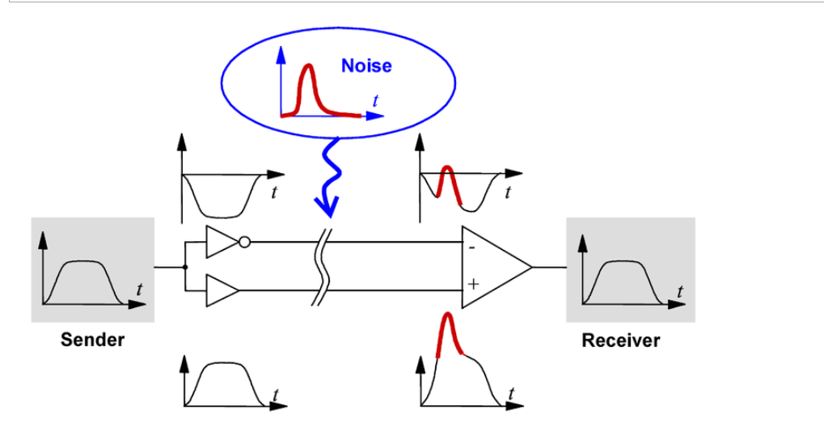
Elimination of noise by using differential signaling.

LOW VOLTAGE DIFFERENTIAL SIGNALING (LVDS)
As a result of internet’s tremendous growth, data transfers are increasing dramatically in all areas of communication. In addition digital streams for digital video, high definition television (HDTV), and color graphics are requiring higher and higher bandwidth. LVDS uses differential signals with low voltage swings to transmit data. LVDS proven speed, noise control, EMI reduction are popular in point to point applications for telecommunication, data communication and displays. LVDS drivers and receivers are primarily used in point to point configuration. Driver is connected to receiver through twisted cable, flat flexible cable (FFC), or simply PCB traces.
Electrical Characteristics of LVDS
An LVDS driver converts a TTL/CMOS signal into a low-voltage differential signal and the receiver then translates the differential signal back into a TTL/CMOS signal. Following figure illustrates a typical LVDS transmitter. This transmitter consists of a current-mode driver, which provides around 3.5 mA of current through the transmission lines of the differential pair. At the receiver, a 100 Ω termination resistor is used to match the impedance of the transmission line that connects the receiver to the driver. Closely matching the impedance of this termination resistor with the impedance of the transmission lines reduces harmful signal reflections that decrease signal quality. The termination resistor also provides a path between the complementary signal paths of the system. The high input impedance of the receiver causes the 3.5 mA current coming from the driver to flow through the 100 Ω termination resistor, resulting in a voltage difference of 350 mV between the receiver inputs. As the path for the current within the driver changes from one path to another, the direction of the current flowing through the termination resistor at the receiver changes as well. The direction of the current through the resistor determines whether a positive or negative differential voltage is read. A positive differential voltage represents logic-high level, and a negative differential voltage represents logic-low level.

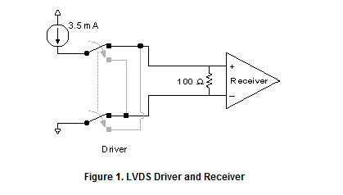
TEST SETUP

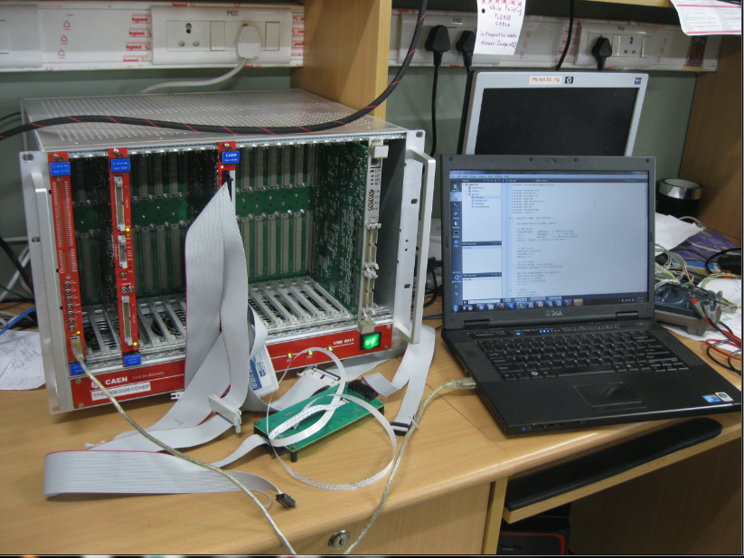
V1495
V830
VME crate
FFC cable

Advantages of LVDS

- Ability to reject common-mode noise
When the two lines of a differential pair run adjacent and in close proximity to one another, environmental noise, such as EMI (electromagnetic interference), is induced upon each line in approximately equal amounts. Because the signal is read as the difference between two voltages, any noise common to both lines of the differential pair is subtracted out at the receiver. The ability to reject common-mode noise in this manner makes LVDS less sensitive to environmental noise and reduces the risk of noise related problems, such as crosstalk from neighboring lines.

- Reduced amount of noise emission
When the two adjacent lines of a differential pair transmit data, current flows in equal and opposite directions, creating equal and opposite electromagnetic fields that cancel one another. The strength of these fields is proportional to the flow of current through the lines. Thus the lower current flow in an LVDS transmission line produces a weaker electromagnetic field than other technologies.

- Flexibility around their power supply
LVDS offers designers flexibility around their power supply solution, working equally well at 5V, 3.3V and lower.

LVDS Transmitter and Receiver

Following are the LVDS transmitter and receiver IC’s we used for our purpose.

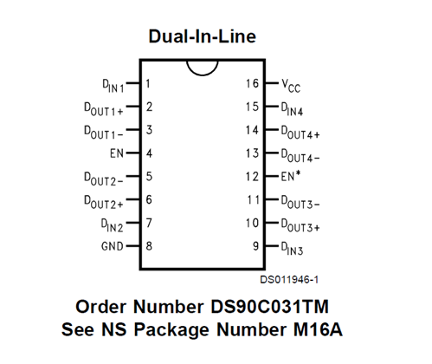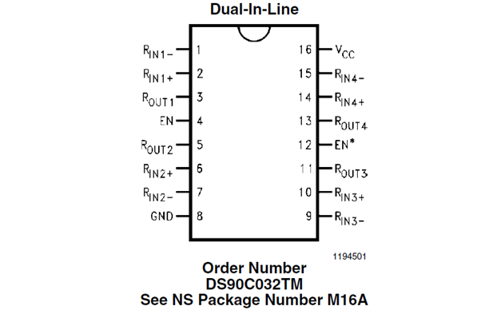

In DS90C031 (Tx) TTL input is given at pin 1,7,9,15. And the LVDS output is derived from pin (2,3),(5,6),(10,11),(13,14). This LVDS output is passed through a media and then feed into DS90C032 (Rx) which converts it back to TTL signal. The output is derived from pin 3,5,11,13.

Block Diagram

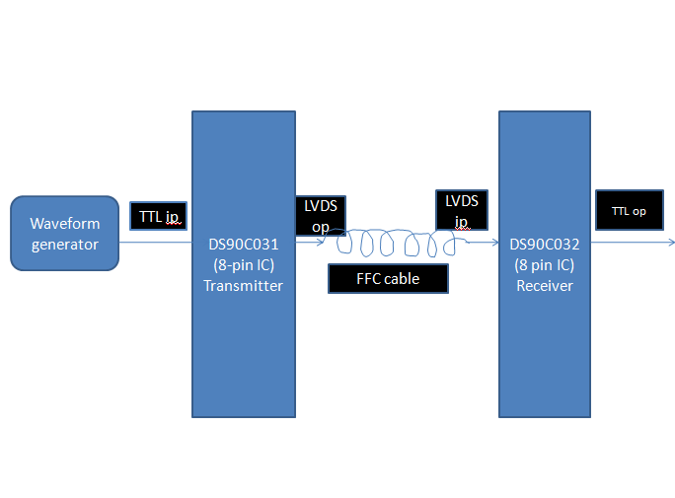
Here we are taking the TTL input from waveform generator and passing it to DS90C031- the transmitter IC which converts it into LVDS signal. This LVDS signal is then passed through FFC cable and the LVDS output of cable is feed into DS90C032- the receiver IC which converts it back to TTL signal.

Observations

LVDS and TTL i/o for 50ns pulse width

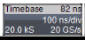
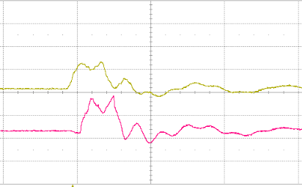
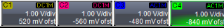
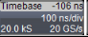
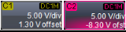
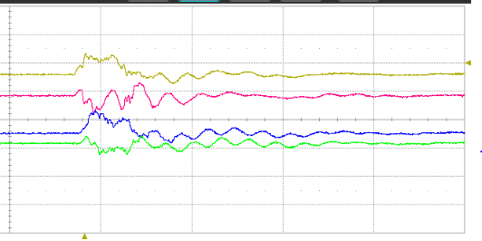

LVDS and TTL i/o for 100ns pulse width
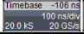
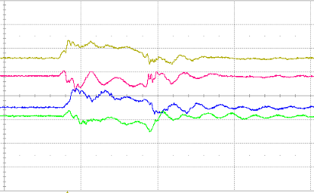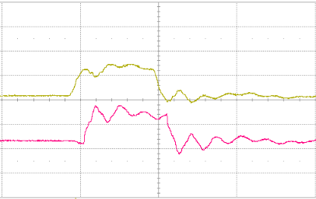
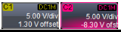
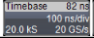
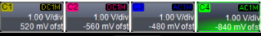

LVDS and TTL i/o for 150ns pulse width
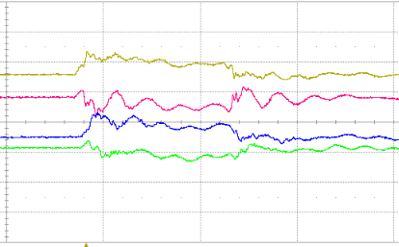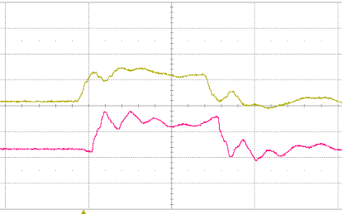
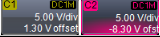
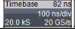
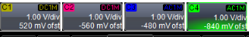

LVDS and TTL i/o for 200ns pulse width

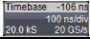
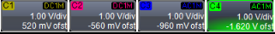
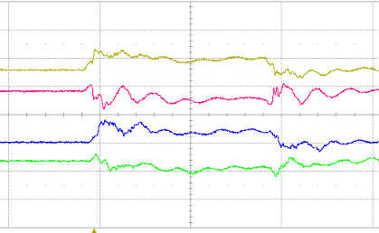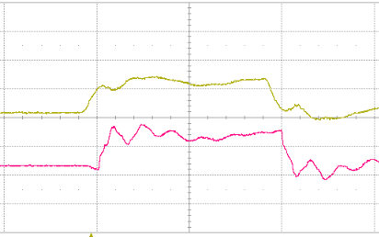
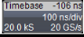
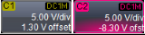

LVDS i/o and TTL o/p for 20 ns pulse width

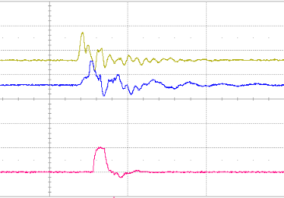
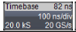
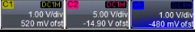

Comment:
Here we can see that as the input pulse width is very small that is of 20ns, so the output signal becomes triangular in shape as the rise fall time is comparable pulse time period.

Pulse Generator
In order to add flexibility to the test system, we have designed a multi-channel pulse generator using CAEN V1495 VME based general purpose mode. This module has two FPGA-Bridge and User. VME interface is built in the Bridge FPGA, while the User FPGA is available for implementing custom user design.
The pulse generator can generate multiple pulses whose pulse width, pulse time period and delay with respect to each other is user programmable. For our purpose we designed it for 8 channels. Following is the screenshot of 4 out of 8 pulses with different time period, pulse width and delay.

Free running mode
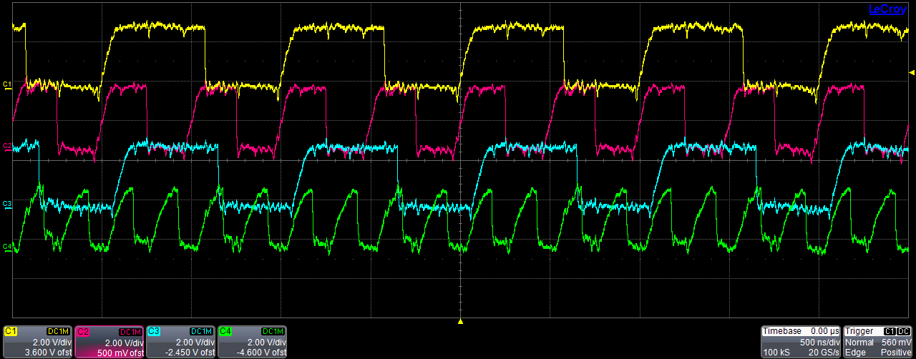
Figure1:
Yellow pulse : 1MHz frequency, 400ns pulse width
Pink pulse : 2 Mhz frequency, 200ns pulse width, delayed by 25ns wrt yellow pulse
Blue pulse : 1 MHz frequency, 400ns pulse width, delayed by 50ns wrt yellow pulse
Green pulse : 4 Mhz frequency, 100ns pulse width, delayed by 75ns wrt yellow puls
Burst Mode
Also we are able to generate burst mode. In this mode no of output pulses to be sent, Time period of the pulse and pulse width are user programmable. Burst pulse is generated in response to a software controllable trigger event.

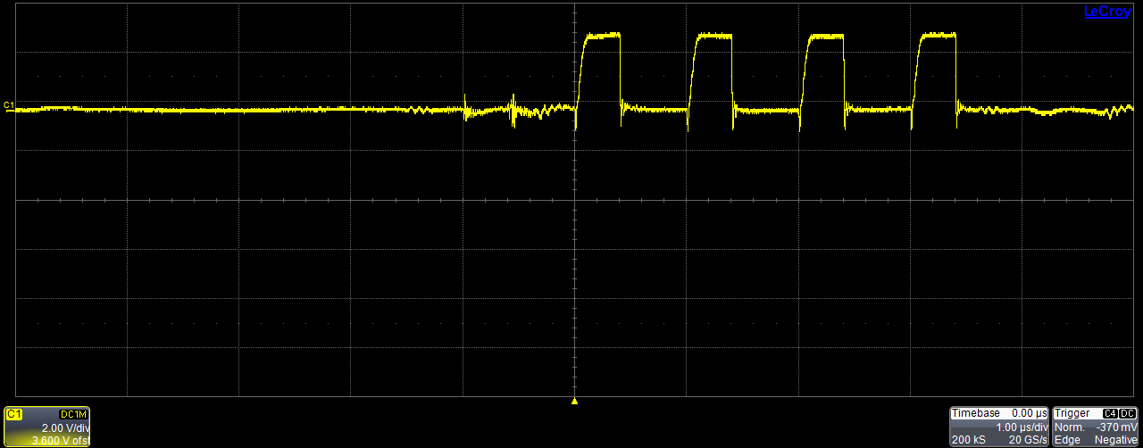
No. of pulses => 4, time period=> 1MHz, pulse width=>400ns
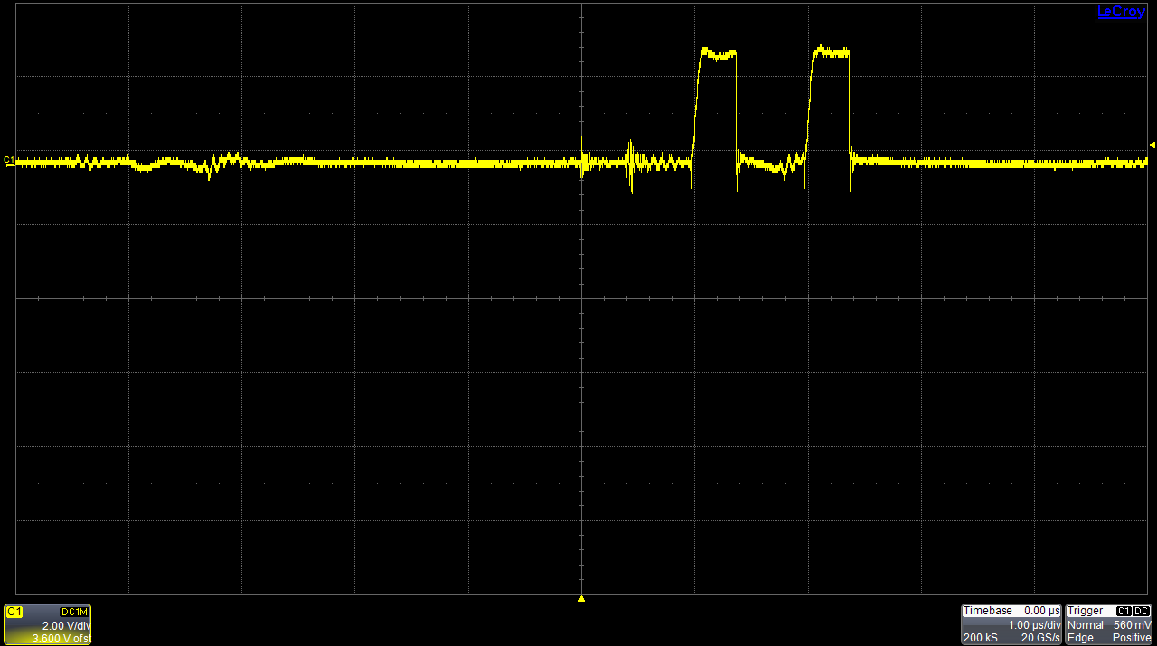
No. of pulses => 2, time period=> 1MHz, pulse width=>400ns

Cross-talk check :
LVDS signals generated by FPGA module is fed into the FFC cable, the output signals are received on the other end of the cable which is fed into a VME scalar. CAEN VME scalar (V830) coding is done to count the pulses and calculate the output signal frequency. The output frequency is then compared with input signal frequency (which is already known). If output signal frequency does not match with input signal frequency then we can say that crosstalk is present.
Observations
Cable length: 15 cm:
- When signal is transmitted through all the 8 channels: (check for bad transmission)
Table1:
Comparison between input and output signal average frequency (data is taken 500 times in a span of 1 sec.)
 | Channel 1 | Channel 2 | Channel 3 | Channel 4 | Channel 5 | Channel 6 | Channel 7 | Channel 8
Input frequency | 1MHz | 2MHz | 4MHz | 1MHz | 2MHz | 4MHz | 1MHz | 2MHz
Output frequency | 1.000001  MHz | 2.000001  MHz | 4.000003  MHz | 1.000001  MHz | 2.000001  MHz | 4.000003  MHz | 1.000001  MHz | 2.000001  MHz
Deviation from input frequency | 0.000001 | 0.0000005 | 0.00000075 | 0.000001 | 0.0000005 | 0.00000075 | 0.000001 | 0.0000005

- Check for crosstalk:
Table2: Signal transmitted on channel 1
 | Channel 1 | Channel 2 | Channel 3 | Channel 4 | Channel 5 | Channel 6 | Channel 7 | Channel 8
Input frequency | 1MHz | 0 | 0 | 0 | 0 | 0 | 0 | 0
Output frequency | 1.000001  MHz | 0 | 0 | 0 | 0 | 0 | 0 | 0

Table3: Signal transmitted on channel 2
 | Channel 1 | Channel 2 | Channel 3 | Channel 4 | Channel 5 | Channel 6 | Channel 7 | Channel 8
Input frequency | 0 | 2 MHz | 0 | 0 | 0 | 0 | 0 | 0
Output frequency | 0 | 2.000001  MHz | 0 | 0 | 0 | 0 | 0 | 0

Table4: Signal transmitted on channel 5
 | Channel 1 | Channel 2 | Channel 3 | Channel 4 | Channel 5 | Channel 6 | Channel 7 | Channel 8
Input frequency | 0 | 0 | 0 | 0 | 2 MHz | 0 | 0 | 0
Output frequency | 0 | 0 | 0 | 0 | 2.000002  MHz | 0 | 0 | 0

Table 5: Signal is transmitted on alternate channels
 | Channel 1 | Channel 2 | Channel 3 | Channel 4 | Channel 5 | Channel 6 | Channel 7 | Channel 8
Input frequency | 1MHz | 0 | 4MHz | 0 | 2 MHz | 0 | 1MHz | 0
Output frequency | 1.000001  MHz | 0 | 4.000003  MHz | 0 | 2.000001  MHz | 0 | 1.000001  MHz | 0

Cable length: 1 m:
- When signal is transmitted through all the 8 channels: (check for bad transmission)
Table 6 : Comparison between input and output signal average frequency (data is taken 500 times in a span of 1 sec.)
 | Channel 1 | Channel 2 | Channel 3 | Channel 4 | Channel 5 | Channel 6 | Channel 7 | Channel 8
Input frequency | 1MHz | 2MHz | 4MHz | 1MHz | 2MHz | 4MHz | 1MHz | 2MHz
Output frequency | 1.000001  MHz | 2.000002  MHz | 4.000003  MHz | 1.000001  MHz | 2.000001  MHz | 4.000003  MHz | 1.000001  MHz | 2.000002  MHz
Deviation from input frequency | 0.000001 | 0.000001 | 0.00000075 | 0.000001 | 0.0000005 | 0.00000075 | 0.000001 | 0.000001
- Check for crosstalk:
Table 7: Signal transmitted on channel 1
 | Channel 1 | Channel 2 | Channel 3 | Channel 4 | Channel 5 | Channel 6 | Channel 7 | Channel 8
Input frequency | 1MHz | 0 | 0 | 0 | 0 | 0 | 0 | 0
Output frequency | 1.000001  MHz | 0 | 0 | 0 | 0 | 0 | 0 | 0

Table 7: Signal transmitted on channel 3
 | Channel 1 | Channel 2 | Channel 3 | Channel 4 | Channel 5 | Channel 6 | Channel 7 | Channel 8
Input frequency | 0 | 0 | 4MHz | 0 | 0 | 0 | 0 | 0
Output frequency | 0 | 0 | 4.000003  MHz | 0 | 0 | 0 | 0 | 0

Table 7: Signal transmitted on channel 6
 | Channel 1 | Channel 2 | Channel 3 | Channel 4 | Channel 5 | Channel 6 | Channel 7 | Channel 8
Input frequency | 0 | 0 | 0 | 0 | 0 | 4MHz | 0 | 0
Output frequency | 0 | 0 | 0 | 0 | 0 | 4.000003  MHz | 0 | 0

Table 5: Signal is transmitted on alternate channels
 | Channel 1 | Channel 2 | Channel 3 | Channel 4 | Channel 5 | Channel 6 | Channel 7 | Channel 8
Input frequency | 1MHz | 0 | 1MHz | 0 | 1MHz | 0 | 1MHz | 0
Output frequency | 1.000001  MHz | 0 | 1.000001  MHz | 0 | 1.000001  MHz | 0 | 1.000001  MHz | 0

Data Transmission Reliability

We must remember that it is not enough that the input and output signal frequency approximately matches. We want to have a situation in which every bit transmitted on FFC cable reaches the destination.
To check the reliability of data sent we used the following approach:
32 bit data is fed into Parallel In Serial Out (PISO) shift register. Output of this register is given as input to FFC cable. Cable output is then fed into Serial In Parallel Out (SIPO) register. By comparing the input data, which is already known, and output data we can check the data transmission reliability.
We have used the FFC cable with 8 pairs of channels. On 7 pairs signals are sent and on 1 pair clock is sent where the no. of clock cycles are same as length of input data string.
Data reliability is checked by transmitting both:
- Constant data in every iteration
- Random data in every iteration

BLOCK DIAGRAM

CONCLUSION
In this project we have studied the LVDS signal transmission characteristics over FFC cable. For this purpose firstly the LVDS transmitter–receiver set-up is used. Next we designed a pulse generator to send data on multiple channels at a time. Output signal frequency is then calculated with the help of CAEN V830 VME module. The observations have indicated that the deviation of output signal frequency from input signal frequency is within tolerable limit and crosstalk between channels is zero. However for reliable data transmission every bit sent must be received on output channel. For this purpose we did bit by bit comparison of input and output data and hence seen that every bit sent is received at the destination correctly.

